There is evidence to suggest that industry portfolios exhibit momentum. What is momentum? Where is the evidence? Industries that have done well in one period also do well in the next period. Why? Why not stocks? Behavior Finance? Industry portfolios constructed in this manner generate returns that may be much larger than the S & P 500 return. Use data prove it!

Investment practitioners believe that asset allocation among bonds, domestic stocks, and foreign stocks should be altered over time depending on individual circumstances and economic conditions. See reference 1 for why? This book proposes taking asset allocation a step further, to allocation among different industries. Why not individual company/stock? Are you assuming there is underlying common events affecting all stocks in the industry, and that effect is large enough? Why? The book’s rational is: One industry may be hot today and another may be hot next month depending on changing fads, individual preferences, national requirements, or political expediency. For example, after the terrorist attacks on September 11, 2001, the defense and security industry did exceptionally well, as demand for such equipment and personnel increased. Similarly, bad weather or continued drought can affect production of commodities and hurt industries that use those inputs. But, this is for efficient market, it doesn’t explain why industry momentum. Industry momentum should be caused by some market inefficiency, such as lagging behind. If changes in an industry are not fleeting but sustained, then a change in stock prices should mirror changes in the industry. Why? It only happens for efficient market where stock prices reflect market circumstances. However, if changes in an industry occor gradually, then stock prices may also change gradually. Change gradually or sustained change? Evidence tends to support gradual movement in industries and in returns of industry portfolios. What is the evidence? This means that compared to an industry that underperforms, an industry that does well in one period is more likely to do well in the next period. Conditional probability should do the evaluation! Such predictability of returns enables the creation and implementation of profitable trading strategies. However, if everyone arbitrage in this manner, it will disappear, right? Essentially, it is market inefficiency?

Evidence

Before presenting evidence related to industry momentum, it is instructive to discuss momentum in individual stocks. There is extensive empirical evidence to suggest profitability of trading strategies based on buying and holding winner stocks. Where is the evidence? In a typical strategy, an investor buys a group of stocks that have done wellover a specified period (winner stocks) and short-sell another group of stocks that have done poorly over the same period (loser stocks). Evdence syggests that this zero investment stratefy generates a positive annual return of up to 12 percent. The strategy doesn’t work for short periods of less than one month or long periods of more than twenty-four months, but is has proven to be successful in the six-to-twelve month range. Do yourself a favor, implement this trading strategy! Some reserachers believe that the momentum is due to herding by institutional investors, when many institutional investors buy the same or similar securities. I agree, trading strategies are based on past stock prices and news, they all looking at the same lagged prediction or some analytst report. Others believe that irrational indicvudal investor behavior is reposnsible for the profitability of momemntum strategies. I agree, any prediction is lagging therefore in that sense, it’s irrational.

There is other evidence to suggest that momentym among individual stocks actually arise from industry momentym., Once individual stocks returns are adjusted for industry effects, momentymn-based trading strategies are much less profitable and largely insignificant. Do yourself a favor, estimate it! This means that the primary reason for momentym is trends in industry. Therefore, industry-momentum-based trading strategies are likely to be better than stratefies based on individual stocks without considering their industry group.

Fidelity Sector Mutual Funds are undiversified single-industry mutual funds designed to capture industry movements with a few stocks. In spite of some shortcomings, fidelity sector funds are a superior vehicle for industry-momentum-based strategies.

The trading strategy

The trading stratefgy is implemented in the following manner: the best-performing fund over a six-month period is chosen and held for the subsequent six momth period. Try difference window please! The book uses data for the Nov 1988 to April 1999p period, the furst estimation period for selection of the best-performing fund is from Nov 1988 to April 1989, and the first holding period for the identidied fund is form May 1989 to October 1989. There are twenty nonoverlapping six-month periods over the May 1989-April 1999 perio. 20 is not a large sample, how to better estimate which is the better performing stock? Tge aforementioned trading strategy would ga egenerated an annualized return of 22.4 percent over the ten-year period. Do yourself a favor, look at other periods! Insterad of using just the single best-performing industry, the risk can beslightly reduced by holding the top 3 industries. Change it please! With 2 insustries, the annualize return falls to 18.7 percent. Risk-return trade off, look at sharpe ratio! Resutslf for varioyus strategies are summarized in Table, which shows that returens improve with longer estimation and longer holding periods. Can you identify a strategy with the optimal sharp ratio?

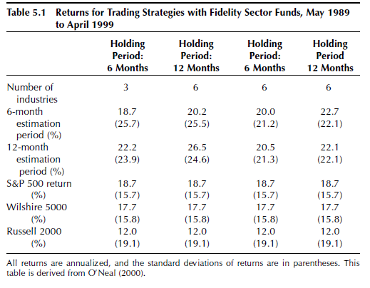

Risk becomes important in momentum-based trading strategies because the portfolio is inadequatrely diversified—only a few industries are selected for investment. It is apprarent that these strategies are claely riskier than holding a broader market portfolio. A simple and commonly used measure of the risk-return trade-off is the Sharpe ratiop. Look reference 2. The ratio is calculated as: Portfolio return-Return on Treasury bills/standard deviation of portfolio return. Report SR along with indexes such as S&P500 holding return, Wilshire 5000 holding return, Russell 2000 holding return.

Risk becomes important in momentum-based trading strategies because the portfolio is inadequatrely diversified—only a few industries are selected for investment. It is apprarent that these strategies are claely riskier than holding a broader market portfolio.

Sector fund trading strategies do not outperform the S&P500 after accounting for risk, I wonder which trading strateges ourperform index after accounting for risk? However, the trading strategies are generally superior when compared with other mutual funds, and other indexes. Provide evidence@ If only the beta risk (or systemactic risk) is considered ( assuming the secto dunds are held in an otherwise well-diversified portfolio), the sector fund trading strategies are superior, in general, to almost all other mutual funds, incld9ing the SP500 index funds.

Explanation

The momentum in individual stock returns and industry returns suggests underreaction to new information that may be inconsistent with market efficiency. What can explain the observed momentum in industry portfolios? There are two broad categories of explanantions: one is based on irrational investor behavior, and the other is baed on efficient markets.

Behaviroal finance theroies attribute underreaction and overreaction to investor irrationality. Accoridng to this explanation, investors are reluctant to change their beliefs quickly even in the face of convincing new information. As a result, they underreact, giving rise to momentum. Smart investors may be unable to take advantage of these biases because their actions are often limited by capital availability an uncertainty.

Another explanantion is related to lags in revisions by analysts. Firms that are industry leaders are followed by many stock analysts, while smaller firms in the same industry are foolowed by fewer analyst. The extent of coverage affects the frequency with which those stocksar reviewed. Leader stocks tend to get reviewed early, with dissemniuation of new information and the consequent orice impact. So industry leaders may have less momentum?? Other industry stocks are reviewed later but experience a similar price impact due to industry wide evemt. The lead-lag relationsip in information dissemination can rsults in the observed momentum.

Besides the behavioral of irrational individual investors, institutional mangers can be responsible for momentum. It is always lwss risky for a manager to go with the crowd than to stick his neck out. Therefore, when a few instituiaonl mangers begint to buy a particular stockm other managers may feel safe in buying the same stock, resulting in momentum, because they have large proportion of capiutal assest in proposal. This is popularly known as herding.

I think irrational behavior part: underreaction and overreaction, herding.

Efficent markets: A rational explanation that is consiten with momentum arises from the realtinsip between financial markets and real assets. While financial asset prices can redlect all available informiatnion, prices of real goods are known to be sticky. Prices of real goods, such as food and housing, move slowly because the demand for these producetrs changes slowly. Since financial market reflect expectations related to markets for real fgoods, financial assets prices also move slowly. One can rightly claim that financial market s should be able to forecast industry porfitablitu depending on forecasts of supply and demand. The problem is that financial markets that can affregate infiraomtin related to forecasts of futures prices do not exist for all industries. For industries with dutures prices, the forecasts are much easier and more accuare, and there may be a smaller momentum effect. Futures markets for commodities sucha s crude oil, orange juice, lumber, hogs, chicken, coffee, cottom, and so on aggretate all publicly available information. No such mechanism aor financial market exists for futures prices of secutirty and defense equipment. The primary sources of information are corporate offiiers and financial analysts, who tend to be conservative in revising estmatees, possibly contributing to the momentum in stock prices. Do yourself a favor, compare industry portfolios with and without futures markets, how to quantify momentum???

Persistence

Given the evidence related to industry momentum, a natural question that foloows is: Why does it still persist? There may be seveal reasons. First, there is a fair amount of skepticism relating to momentum in sprice of the evidence. More work is needed to convince investors that individual stock momentum or industry momentym exisits, Once that happens, investors may feel more onfident about taking positions to arbitrage and evenrtually emilicate momemtum. Second, no clear explanations have emerged to explain momentum. Besides failing to convince the oridinary investor, behavioral explanantions introduce greater riskl and uncertainty because investor behacor can change without warning. Lack of an adequate explanation increases the skeptism with results. Third, the evidence related to individual stock momentum not attributable to industries is strongest at periods of intermediate length (6 to 12 months).

The skeptism of industry momentum becomes more critical because the evidence of industry-baed momentum is new.

Trading Process and Strategy Implementation

Step1: The first step is to identify and choose broad industries. Fidelity’s fourty-one sector funds are a good starting point. HOever, each fund need not represent a distribnct industry. Some of the fidelity funds belong to the same industry and even have considerable overlap. The final sample consists of twenty-four industries.

Step2: In addition to the Fidenlity funds, pick other sector mutual funds that fit into the twenty-four indusrties, irrespective of the fund family. These other funds come from Morningstar’s Principia Pro, which has a fairly broad coverage of mnutual funds.

Step3:

Step4: Obtain historical prices, use time series analysis to show that returns are random walk, and visualiza returns with SP500

Step5: To select funds for the trading strategy, cauculate the periodic retrn, Then calculate the mean overall return for 24 industries. Can we compare with S&P500 as benchmark?? Some regression or modeling?

Step6: The strategy is to choose sectors whose return exceeds the mean return for all industries.

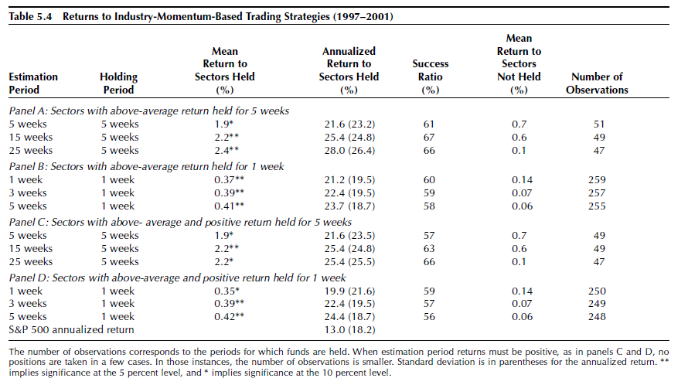

How to choose estimation period and holding period? Issues with longer holding period: results with longer holding periods do not generate enough observatiobns, making statistical testing ineffective. The book recommednationis to use a 5-week bholding period. An estimation period is the prior period over which actual returns are measured to categorize the sectos aas underperforming or overperforming secto, The holding period is the subvsequent period durin which the trading strategy is implemented by inversting in only the overperforming sectors.

Result Discussion

Results for a holding period of X are reported in panels A and C of Table . The estimation periods for portfolio formation are … Funds in industriees that exceed the mean return durint the estimation period are held for a subsequent X period. The return for the 5-weel holding with a 5-week estimation period is 1.9 percent, or 21.6 oercent annualized, significantly greater than zero in a statical and economic sense. The return is posistie 61 percent of the time. At the same time, funds in industries that earned below rth emean return int eh preceding estimation period earned only 0.7 percent, in the holding period, which is statically not different from zzero. Duringt the same 199702991 period, the SP500’s return was a statistically insignificant 1.2 percent.

The table shows that returns and success ratios are generally higher for very long estimation periods. This means that the past 25-week’s retusn is a bettern predictor of the next period’s return than than past 5-week’s return/ In addition, the return to sectors not held decreases as the estimation period increases, implying the superiority of the longer estimation period. Statistically, longer estimation period means what?? On the other hand, the results are not very differnert across different holding and estimateion periods. What does that mean?

In panel C and D, a slightly difference selection process is used for choosing the sectors to be held. In stead of holding all sectos with a return above the emans in the estimation period, an addiaitonal conditioan is imposed: the return of sector musrt be positive. However, the resutlsreveal that neither the return nor the sucees ratriosare higher with this additional condition thatn the results in panels A and B without the added screen.

It is important to take risk into account because industry-momentum-based trading stratefies are clearly risker than boilding a broader market portfikio. The Sharpe ratio is used to compare the risk-adjusted returns. Since higher Sharpe ratios indicare superior inverstment, the best results are for the 1-week holding period, wirh a ratio of 1.05. IN any case, all industry-momenmtum-based trading stratefies have a significantly better Sharpe ratio than a buy-and-hold S&P500 strategy, which has a Sharpe ratio only 0.49.

The difference in returns between sectos held and sectos not held is reassuring because it suggests that superior performance of sectos held is unlikely to be accidental. What does it imply firther??

Implementation for Industries with and Without futures markets

It is possible to improve returns from an industry0momentum-based trading strategy buy relying on the rational explanation that industry momentum probably exisits for industris that do not have futures makets. Futures markets, like other financial markets, are aggregators of information. Dince commodity futures proices capture information anout trends in commodity prices, participanbts in financial markets can make better-informed decisions in industries dependent on commodities with traded futures amrkets than in industries without futures markets.

If the futures markets’s explanation is indeed true, then industries with future markets will ehibit much less momentuym than industries without futures markets. And selecting only industries without futures markets will sharpen and strengthen the gains due to industry momentum. From efficient market view, industries without future markets might be less efficicent, hence morpe irrational behavior.

Commodity futures represent a significant part of the folowin industries: Gold, Energy, Energy services, Airlines, Natial resoures, Food. Sectors are divided into two groups: one where futues markets exist and the other where fures amrketrs don’t exiost. Industry-momentum-based stratefoes are cosntruced separately for the two groups.

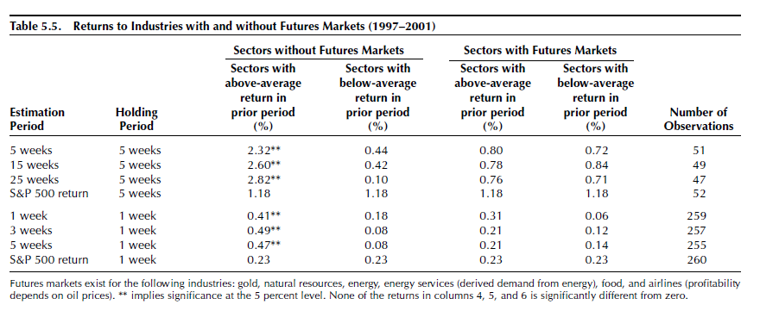

The resutlks are in Table. Three points need emphasis. First, in sectors with futures markets, there is no evidence of any industry momentym, Whether well-performing sectos are held or poorly performing sectos are held, the returns for the -5 week holding period are in the 0.70-0.85 percent range. There is no perceptible difference betweent the well-performing and poorly performing subsamples. On the other hand, there is clear and strong eicdence of industry momentum in sectos without future markets. Well-perfoming sectos in the estimation period outperform the other secots durint the holdin period. The results for the 1-week holding period ar esimlilar to those for the 5-week holding period. The obvious implication is that industry momemntum occurs only for sectos where furures marketrs do not exist. Finally, the results based on sectos without durues markets arte somewhat stronger than thenreutls in Table. Therefore, it is preferable to concentrate only bon sectos without futures amrkes when construcitn g trading strategies based on industry momentum.

The evidence and trading strategy recommendations presented in the book reply on past data. Since future market conditions and market patterns may be completely different, there is no certainty industry momentyn will continue in the future or be profitable. What is it has been elimited away? This paper can be viewed as an empirical validation.

Bottom Line

Momentum within an industry suggests that investors can actually chase wining sectos and priofit from them. Fidelity sector funds offer an easy way to switch among different “hot” sectos. Industry funds that outperform the average industry fund over 6-month period are likely to generate annyal abnormal returns of more than 10 percent. The Sharpe rateio, which accounts for risk, is much higher for an industry-momentumbased traifn strategy thatn for the S&P 500.

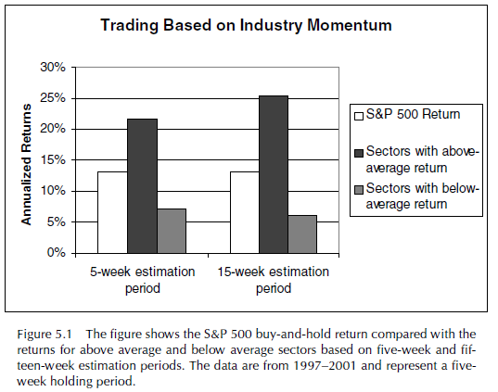

References

Grundy, Bruce D., and J. Spencer Martin. 2001. Understanding the Nature of the

Risks and the Source of the Rewards to Momentum Investing. *Review of Financial*

*Studies* 14(1): 29–78.

Jegadeesh, Narasimhan, and Sheridan Titman. 1993. Returns to Buying Winners

and Selling Losers: Implications for Stock Market Efficiency. *Journal of Finance*

48(1), 65–92.

Moskowitz, Tobias, and Mark Grinblatt. 1999. Do Industries Explain Momentum?

*Journal of Finance* 54(4), 1249–90.

O’Neal, Edward S. 2000. Industry Momentum and Sector Mutual Funds. *Financial*

*Analyst Journal* 56(4), 37–49.

Industry Momentum and Sector Mutual Funds

Recent academic research has ascribed the intermediate-term (3-month to 12-month) momentum present in US stock returns to an industry effect. In the intermediate term, strong (weak) industry performance is followed by continued strong (weak) industry performance. The industry-specific aspect of momentum gives rise to profitable trading strategies that use industry-sector mutual funds. In this study, strategies of buyiung previous intermediate-term top-performaing sector funds outstripped the SP500 Index over the 10-year period from May 1989 through April 1999 on a total-return basis. These strategies entailed greater total and systematic risk, however, than the index.

Momentum in stock returns is the tendency for wekk-performing stocks to continue perform well and for poor performers to continue to perform poorly. This positive serial correlation has been documented for U>S> common stock returns for holding periods in the 3- to 12-month range. The most recent academic evidence on momentum suggests that the bulk of the observed momentum in these intermediate-term individual stock returns is an industry effect. Could the industry aspect of momentyum facilitate prqactitioner exploitation of this phenomenon? This article explores one mechanism for capturing industry momentum profits – trading strategies involving industry-sector mutual funds.

Jegadeesh and Titman (1993) explored intermediate-term correlations in the 1965-89 period nad incovered momentum for 3- to 12- month holding periods. The strategy of selecting US. Stocks on the bassis of their performance in the previous six months and holding the portfolio for six months realized abnormal returns of 12 percent a year. Moskowitz and Grinblatt (1999) attributed the bulk of the observed momentum in intermediate-term individual stock returns to industry momentum—the tendency for stock return patterns at the industry level to persist. The aurthors formed self-financing portfolios that went long on past winners and short on past losers for the subsequent study period (the “hold period”). Moskowitz and Grinblatt explored this self-financing strategy for lag and old periods of varius lengths but concentrated their analysis on six-month lag and six-month hold periods, which they denoted 6,6. Profits average 0.43 percent a month. Because shorting can present problems for investors, they identified what portion of the return came from winning portfolio and what portion came from loser portfolio. Of the 0.43 percent a month for the 6,6 strategy, 0.37 percent came from winners and the remaining 0.06 percent came from losers.